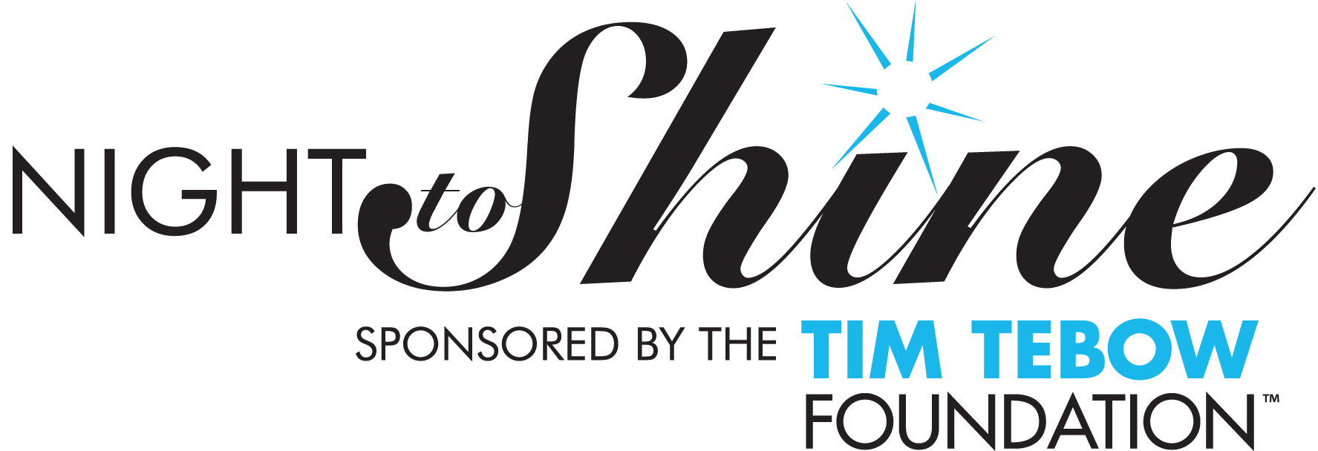

Volunteer Permission Slip (Volunteers Under Age 18)
Must be at least 16

I give my permission for ___________________________to participate as a volunteer at the
PARTICIPANT FULL NAME
2023 Night to Shine, sponsored by the Tim Tebow Foundation at_____________________
CrossPoint Church
on Friday, February 10, 2023.

Volunteer Information

DOB: ________________________ Gender: Female: □ Male: □

Address: ______________________________________________________________________________

City: _______________________________ State: _________ Zip Code: ___________________

Phone: ______________________________

Parent / Guardian Phone (Home): __________________________________________________________________

Parent / Guardian Phone (Cell): ___________________________________________________________________

Desired Volunteer Role: _______________________________________________

Parent Signature: ________________________________________ Date: _____________

Parent Printed Name: _____________________________________

Remit form to: Mandi Logan

