FOR IMMEDIATE RELEASE
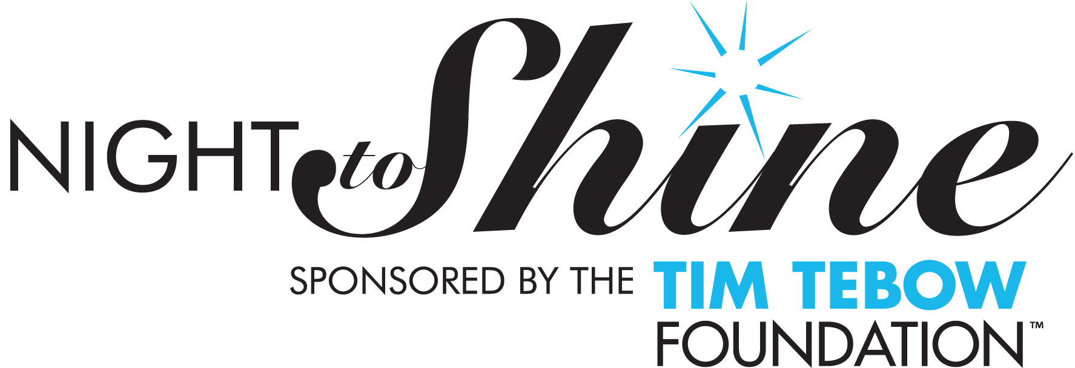
{DATE}

Media Contact:
Name
{Phone}
{Email}

CrossPoint Church to Host Night to Shine Prom for People with Exceptional Needs
Sponsored by Tim Tebow Foundation

Trussville, Alabama, (Date) – CrossPiont Church announced today that they will serve as a host of Night to Shine 2024, sponsored by the Tim Tebow Foundation. The unforgettable prom night experience, centered on God’s love, celebrating people with special needs will be held in-person by host churches around the world simultaneously on Friday, February 9, 2024 at CrossPoint Church, 8000 Liles Lane, Trussville, AL. CrossPoint Church is excited to be a part of this worldwide movement that God is using as a catalyst to change how cultures embrace people with disabilities and to rally the church worldwide to honor their local community of people with special needs, ensuring they know they are valued and loved.

Every guest of Night to Shine enters this complimentary event on a red carpet complete with a warm welcome from a friendly crowd and paparazzi. Once inside, guests receive the royal treatment, including hair and makeup stations, shoe shining areas, corsages and boutonnieres, a food, live music, prom favors, a dance floor… all leading up to the moment when each guest is crowned king or queen of the prom.

Night to Shine launched in 2015 with 44 host churches and 15,000 volunteers honoring more than 7,000 kings and queens of the prom. In February 2020, 721 host churches and 215,000 volunteers came together to celebrate 110,000 honored guests with special needs. Over the past two years, Night to Shine innovated and endured through the pandemic with the first-ever virtual Night to Shine, celebrating thousands of honored guests through unique adaptations including a complete virtual video experience and socially distanced Shine Thru drive-thru events.

For additional information on the Night to Shine hosted by CrossPoint Church in Trussvile, visit
info@crosspointchurch.info
For more information on the worldwide movement of Night to Shine, sponsored by the Tim Tebow Foundation, visit: www.timtebowfoundation.org/night-to-shine

ABOUT CrossPoint Church
CrossPoint Church exists to glorify God by reaching JUST ONE MORE to become a fully devoted follower of Jesus Christ.

ABOUT TIM TEBOW FOUNDATION
The Tim Tebow Foundation exists to bring Faith, Hope and Love to those needing a brighter day in their darkest hour of need. This mission is being fulfilled every day through 16 initiatives in the fields of Orphan Care + Prevention, Special Needs, Children with Profound Medical Needs, and Anti-Human Trafficking. To learn more about how the Tim Tebow Foundation is serving the world’s most vulnerable and sharing God’s love by fighting for those who can’t fight for themselves, visit www.timtebowfoundation.org.

